Notebook Execution Report
Hybrid AI loan decisioning (XGBoost + Granite RAG) and MNIST digit recognition on IBM LinuxONE
Report date: 17 October 2026

1. Executive summary
This report covers two further notebook executions: a loan-decisioning pipeline that combines predictive and generative AI, and a basic MNIST digit classifier. For each, it gives the code that was run, the output produced, and an interpretation.
 | Notebook 3: Loan decisioning | Notebook 4: MNIST digits
Framework | XGBoost GBTree, llama.cpp with an IBM Granite GGUF model, BM25 retrieval | TensorFlow 2.18.1 / Keras dense network; ONNX export
Data | Applicant 5: loan record, bank statement, pay stub, W-2 PDFs | 60,000 training and 10,000 test images (28 x 28)
Result | Low Risk (p = 0.9974); recommendation: Approve | Test accuracy 95.05%; 255,246 images/s
Main concern | Loaded model differs from the one the notebook says it expects; zDNN library reads 0.0 MB | Validation metrics are identical in all 5 epochs, which looks like a bug

Note on images. Only text output was supplied, so the original images (MNIST sample digit, training-curve plot, the ten-digit prediction strip, architecture diagram) could not be reproduced. The MNIST data download is also blocked from my environment. The figures here are drawn from the numbers the notebooks printed. Re-running the notebooks and exporting the figures would let me insert the originals.

2. Notebook 3: Predictive and generative AI for loan decisioning
The pipeline has four stages: (1) a generative model extracts financial features from the applicant's PDFs; (2) an XGBoost model scores risk from structured loan data; (3) BM25 retrieves relevant lending-policy text, and the language model combines everything into an Approve/Reject recommendation; (4) the user can ask follow-up questions about the decision.

2.1 Setup and model loading
Code
import pandas as pd
from loan_demo.model_utils import predict_risk
from loan_demo.pdf_utils import extract_text_from_pdf
from loan_demo.rag_utils import (load_model, load_policy_docs, compress_applicant_documents,
extract_document_features, generate_recommendation, generate_answer,
build_policy_index, summarize_applicant)

# Load IBM Granite model used for generative AI
model = load_model()

Output
llama_kv_cache: the V embeddings have different sizes across layers and FA is not enabled - padding V cache to 256

The message is an informational llama.cpp note about the key-value cache layout, not an error.

2.2 Acceleration and model verification
The notebook describes two llama.cpp back ends: zDNN/NNPA for matrix multiplication and OpenBLAS for vector-extension GEMM. The cell checks the package version, the zDNN library, and the model file.
Code
import glob, os, importlib.metadata

llama_version = importlib.metadata.version('llama_cpp_python')
print(f'llama_cpp_python version : {llama_version}')

zdnn_libs = glob.glob('/opt/venv/lib*/python3.12/site-packages/llama_cpp/lib/libggml-zdnn*.so')
if zdnn_libs:
for lib in zdnn_libs:
size_mb = os.path.getsize(lib) / 1024**2
print(f'zDNN shared library : {lib} ({size_mb:.1f} MB)')
else:
print('WARNING: libggml-zdnn.so not found - NNPA acceleration inactive')

try:
from llama_cpp import llama_cpp as _lc
supports_gpu = getattr(_lc, 'llama_supports_gpu_offload', None)
print(f'GPU offload support : {supports_gpu() if supports_gpu else "n/a"}')
except Exception:
pass

from loan_demo.rag_utils import MODEL_PATH
if os.path.exists(MODEL_PATH):
size_mb = os.path.getsize(MODEL_PATH) / 1024**2
with open(MODEL_PATH, 'rb') as f:
magic = f.read(4)
valid = magic == b'GGUF'
print(f'Granite model : {MODEL_PATH}')
print(f' Size : {size_mb:.0f} MB')
print(f' GGUF magic : {magic} ({"valid" if valid else "INVALID"})')
print(f' Expected : granite-3.3-2b-instruct-be.Q4_K_M (s390x)')
else:
print(f'WARNING: model file not found at {MODEL_PATH}')

print('Build flags used for this container:')
for flag in ['-DGGML_ZDNN=ON', '-DGGML_BLAS=ON', '-DGGML_BLAS_VENDOR=OpenBLAS',
'-DCMAKE_C_FLAGS=-march=z16', '-DCMAKE_CXX_FLAGS=-march=z16']:
print(f' {flag}')

Output
llama_cpp_python version : 0.3.36
zDNN shared library : /opt/venv/lib/python3.12/site-packages/llama_cpp/lib/libggml-zdnn.so (0.0 MB)
zDNN shared library : /opt/venv/lib64/python3.12/site-packages/llama_cpp/lib/libggml-zdnn.so (0.0 MB)
GPU offload support : False
Granite model : /home/ibm-user/granite-4.0-h-350m-base-be.f16.gguf
Size : 653 MB
GGUF magic : b'GGUF' (valid)
Expected : granite-3.3-2b-instruct-be.Q4_K_M (s390x)

Build flags used for this container:
-DGGML_ZDNN=ON -DGGML_BLAS=ON -DGGML_BLAS_VENDOR=OpenBLAS
-DCMAKE_C_FLAGS=-march=z16 -DCMAKE_CXX_FLAGS=-march=z16

Three results here need attention. The zDNN library file reports 0.0 MB, which suggests an empty or stub file (or one that rounds below 0.05 MB), so it does not confirm that acceleration is available. The model on disk is granite-4.0-h-350m-base (f16, 653 MB), not the granite-3.3-2b-instruct Q4_K_M the cell expects, and the check only validates the GGUF header, so the mismatch is printed but not acted on. Finally, the build flags are hard-coded text, not read from the library.

2.3 Loading applicant documents
Applicant 5's loan row and three PDFs are loaded and compressed into a short summary string.
Code
APPLICANT_ID = 5

loan_df = pd.read_csv("sample_data/sample_loan.csv")
loan = loan_df.iloc[APPLICANT_ID - 1].to_dict()

bank_pdf = f"sample_data/bank_statements/{APPLICANT_ID}.pdf"
paystub_pdf = f"sample_data/pay_stubs/{APPLICANT_ID}.pdf"
w2_pdf = f"sample_data/w2/{APPLICANT_ID}.pdf"

bank_text = extract_text_from_pdf(bank_pdf)
paystub_text = extract_text_from_pdf(paystub_pdf)
w2_text = extract_text_from_pdf(w2_pdf)

# additional preprocessing and cleanup of extracted text
document_text = compress_applicant_documents(bank_text, paystub_text, w2_text)
print(document_text)

# Use the model to extract features from unstructured documents
document_features = extract_document_features(model, document_text)

Output
Bank: opening=25,588.90, closing=146,746.07, credits=167,624.44, debits=46,467.27, cashflow=positive

Paystub: ytd_gross=264,633.60, ytd_deductions=61,262.68,ytd_net=203,370.92, gross_pay=24,259.72, net_pay=18,643.59

W2 Latest: wages=282,112.20, federal_tax=62,064.68

Financial Stability: High
Cash Flow Stability: High
Income Consistency: High
Compliance Status: Compliant

Evidence:
Bank: opening=25,588.90, closing=146,746.07, credits=167,624.

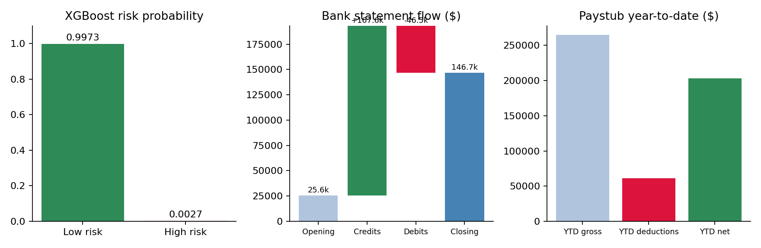
Figure 1. Risk probability, bank-statement flow and pay-stub totals for applicant 5 (from printed values).
The extracted figures are internally consistent: opening balance plus credits minus debits equals the closing balance (25,588.90 + 167,624.44 - 46,467.27 = 146,746.07), and gross pay minus deductions equals net pay year to date (264,633.60 - 61,262.68 = 203,370.92). Federal tax is about 22% of W-2 wages. The model rated all four features favourably. The "Evidence" line is cut off mid-number ("167,624."), so the model output appears truncated by a token or length limit.

2.4 Risk prediction, policy retrieval and recommendation
Code
risk_result = predict_risk(loan)
print(risk_result)

policies = load_policy_docs("sample_data/policy")
bm25, policy_chunks = build_policy_index(policies, chunk_size=300)

recommendation = generate_recommendation(
model=model, applicant=loan, risk_result=risk_result,
document_features=document_features, bm25=bm25, policy_chunks=policy_chunks)

Output
{'risk': 'Low Risk', 'probability_low': 0.9973529772689301, 'probability_high': 0.0026470227310690002}

Recommendation: Approve
Main Reason: High credit score, low DTI and stable documented income meet policy.

XGBoost gives 99.74% probability of low risk. The policy index uses 300-character chunks. The recommendation text cites a high credit score and low debt-to-income ratio; these fields come from the loan record, which was not printed, so they cannot be verified from this output.

2.5 Question answering
Code
applicant_summary = summarize_applicant(loan)

context = f"""
Applicant:
{applicant_summary}

Risk:
{risk_result}

Document Analysis:
{document_features}

Recommendation:
{recommendation}
"""

response = generate_answer(model, context, "Why was this applicant considered low risk?")

Output
Q: Why was this applicant considered low risk?
A: The applicant has a high credit score and strong income relative to the loan amount. Documents show positive cash flow, consistent income and compliance, and the risk model predicts low risk.

The answer is faithful to the supplied context: it restates the document findings and the risk-model result and adds nothing unsupported.

3. Notebook 4: MNIST handwritten digit recognition
A small fully connected network (784 - 128 - 10 with 20% dropout) is trained for five epochs on MNIST, evaluated on the test set, exported to ONNX and SavedModel formats, and benchmarked.

3.1 Data loading
Code
import os
os.environ['TF_CPP_MIN_LOG_LEVEL'] = '2'
import matplotlib.pyplot as plt
import tensorflow as tf
print('TensorFlow version:', tf.__version__)

mnist = tf.keras.datasets.mnist
(x_train, y_train), (x_test, y_test) = mnist.load_data()
x_train, x_test = x_train / 255.0, x_test / 255.0

print(x_train.shape, y_train.shape, x_test.shape, y_test.shape)
plt.imshow(x_train[5]).set_cmap('Greys')

Output
TensorFlow version: 2.18.1
Downloading data from .../mnist.npz 11490434/11490434 - 0s
((60000, 28, 28), (60000,), (10000, 28, 28), (10000,))

Pixel values are scaled to the 0-1 range. A sample image (x_train[5]) was plotted in the original, but its image is not included in the text.

3.2 Model definition
Code
model = tf.keras.models.Sequential([
tf.keras.Input(shape=(28, 28)),
tf.keras.layers.Flatten(),
tf.keras.layers.Dense(128, activation='relu'),
tf.keras.layers.Dropout(0.2),
tf.keras.layers.Dense(10)
])
model.summary()

loss_fn = tf.keras.losses.SparseCategoricalCrossentropy(from_logits=True)
model.compile(optimizer='adam', loss=loss_fn, metrics=['accuracy'])

sample_logits = model(x_train[:1])
print('Logits shape:', sample_logits.shape)
print('Probabilities:', tf.nn.softmax(sample_logits).numpy())

Output
Layer (type) Output Shape Param #
flatten (None, 784) 0
dense (None, 128) 100,480
dropout (None, 128) 0
dense_1 (None, 10) 1,290
Total params: 101,770 (397.54 KB)

Logits shape: (1, 10)
Probabilities: [[0.0695 0.0781 0.1094 0.0852 0.1009 0.1955 0.0647 0.1027 0.1207 0.0734]]

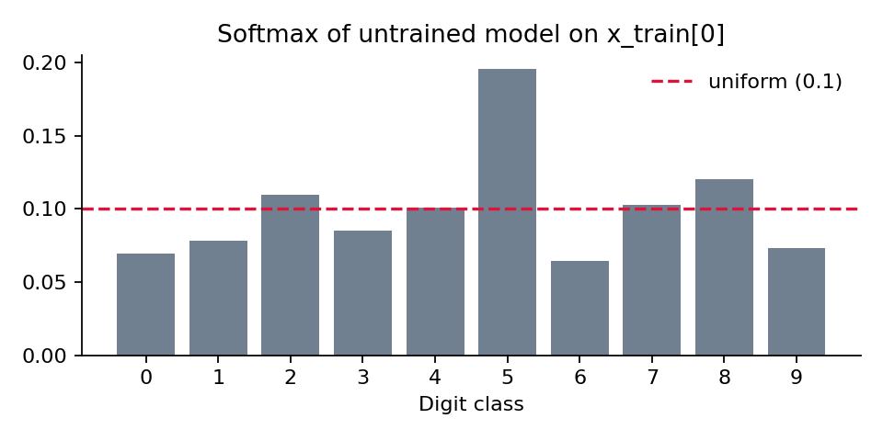
Figure 2. Output of the untrained model on one image: probabilities are close to uniform, as expected.

3.3 Training and evaluation
Code
history = model.fit(x_train, y_train, epochs=5, validation_split=0.1)

test_loss, test_acc = model.evaluate(x_test, y_test, verbose=2)
print(f'\nTest accuracy: {test_acc:.4f}')

fig, (ax1, ax2) = plt.subplots(1, 2, figsize=(12, 4))
ax1.plot(history.history['accuracy'], label='train')
ax1.plot(history.history['val_accuracy'], label='val')
ax1.set_title('Accuracy'); ax1.legend()
ax2.plot(history.history['loss'], label='train')
ax2.plot(history.history['val_loss'], label='val')
ax2.set_title('Loss'); ax2.legend()
plt.tight_layout(); plt.show()

Output
Epoch 1/5 1688/1688 - 3s 1ms/step - accuracy: 0.8999 - loss: 0.3407 - val_accuracy: 0.9628 - val_loss: 0.1427
Epoch 2/5 1688/1688 - 2s 1ms/step - accuracy: 0.9486 - loss: 0.1736 - val_accuracy: 0.9628 - val_loss: 0.1427
Epoch 3/5 1688/1688 - 2s 1ms/step - accuracy: 0.9620 - loss: 0.1266 - val_accuracy: 0.9628 - val_loss: 0.1427
Epoch 4/5 1688/1688 - 2s 1ms/step - accuracy: 0.9688 - loss: 0.1034 - val_accuracy: 0.9628 - val_loss: 0.1427
Epoch 5/5 1688/1688 - 2s 1ms/step - accuracy: 0.9721 - loss: 0.0897 - val_accuracy: 0.9628 - val_loss: 0.1427

313/313 - 0s - 606us/step - accuracy: 0.9505 - loss: 0.1688
Test accuracy: 0.9505

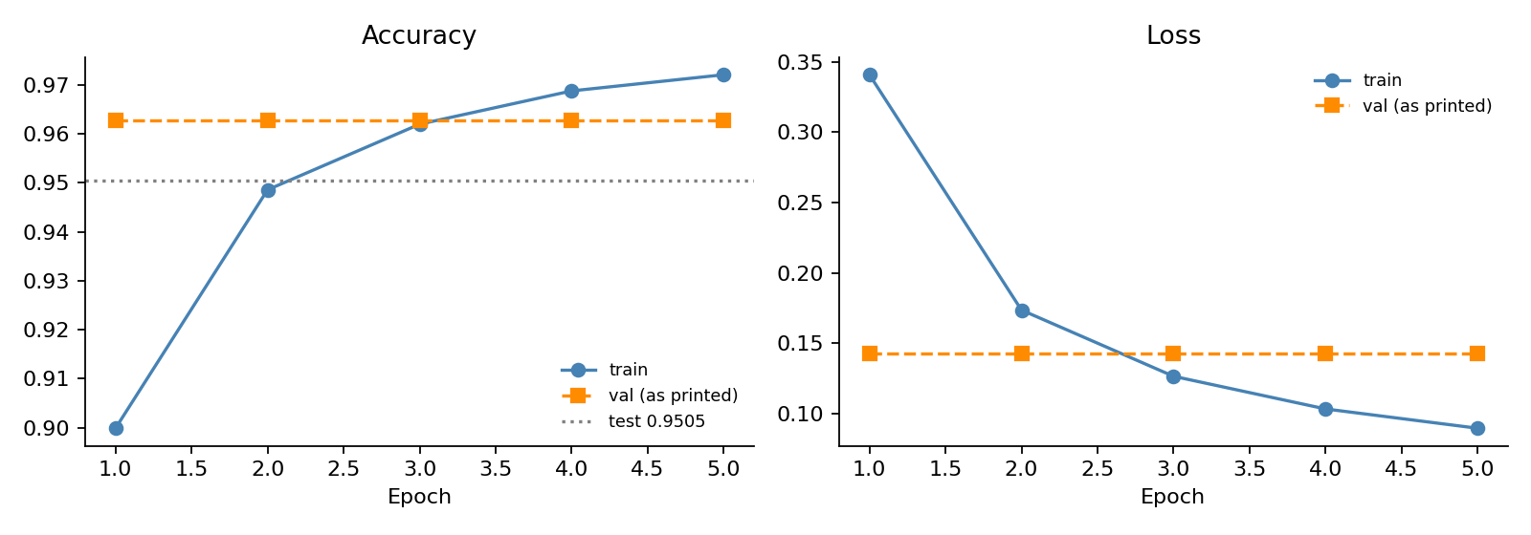
Figure 3. Training accuracy and loss per epoch. Validation values are plotted exactly as printed (constant).
Training accuracy rose from 90.0% to 97.2% and training loss fell from 0.341 to 0.090. The validation numbers, however, are exactly 0.9628 and 0.1427 in every epoch. A model that is learning would change these values, so this is most likely a logging or notebook artefact (for example copied output from one epoch) rather than a real result. The test accuracy of 95.05% is lower than the validation figure and the final training accuracy, which would fit mild overfitting; for this architecture, test accuracy near 97 to 98% is more typical after five epochs, so re-running is advisable.

3.4 ONNX and SavedModel export
Code
import tf2onnx, onnx

input_signature = [tf.TensorSpec([None, 28, 28], tf.float32, name='input')]
@tf.function(input_signature=input_signature)
def model_fn(x):
return model(x)

onnx_model, _ = tf2onnx.convert.from_function(model_fn, input_signature=input_signature, opset=13)
onnx.save_model(onnx_model, 'mnist_seqdnn.onnx')
print('Saved mnist_seqdnn.onnx')

model.export('mnist_seqdnn')
print('Saved mnist_seqdnn/')

Output
Saved mnist_seqdnn.onnx
INFO:tensorflow:Assets written to: mnist_seqdnn/assets
Saved artifact at 'mnist_seqdnn' (input (None, 28, 28) -> output (None, 10))
Saved mnist_seqdnn/

3.5 zDNN check, benchmark and predictions
Code
import importlib.metadata, time, glob
import numpy as np

zdnn_version = importlib.metadata.version('ibm-zdnn-plugin')
print(f'ibm-zdnn-plugin version : {zdnn_version}')
so_path = glob.glob('/opt/venv/lib*/python3.12/site-packages/tensorflow/core/kernels/_z_ops.so')
if so_path:
size_mb = os.path.getsize(so_path[0]) / 1024**2
print(f'zDNN kernel library : {so_path[0]} ({size_mb:.1f} MB loaded)')
else:
print('WARNING: _z_ops.so not found - NNPA acceleration inactive')
print(f'TensorFlow device : {tf.config.list_physical_devices()}')
for op in ['MatMul / Dense forward pass', 'Relu activation', 'Softmax',
'Dropout (inference no-op)', 'BatchMatMul']:
print(f' OK {op}')

_ = model(x_test[:1]) # warm up

BATCH, REPEATS = 1000, 20
sample = x_test[:BATCH].astype('float32')
times = []
for _ in range(REPEATS):
t0 = time.perf_counter()
preds = model(sample, training=False)
_ = preds.numpy()
times.append(time.perf_counter() - t0)
times = sorted(times)
median_ms = times[len(times)//2] * 1000
best_ms = times[0] * 1000
throughput = BATCH / (median_ms / 1000)

# Predictions on 10 test images
n = 10
sample_images = x_test[:n]
logits = model(sample_images, training=False)
pred_labels = tf.argmax(tf.nn.softmax(logits), axis=1).numpy()
true_labels = y_test[:n]
fig, axes = plt.subplots(1, n, figsize=(15, 2))
for i, ax in enumerate(axes):
ax.imshow(sample_images[i], cmap='Greys')
colour = 'green' if pred_labels[i] == true_labels[i] else 'red'
ax.set_title(f'pred:{pred_labels[i]}\ntrue:{true_labels[i]}', color=colour, fontsize=8)
ax.axis('off')
plt.show()

Output
ibm-zdnn-plugin version : 2.3.0
zDNN kernel library : /opt/venv/lib/python3.12/site-packages/tensorflow/core/kernels/_z_ops.so (17.5 MB loaded)
TensorFlow device : [PhysicalDevice(name='/physical_device:CPU:0', device_type='CPU')]
OK MatMul / Dense forward pass, Relu, Softmax, Dropout (no-op), BatchMatMul

Batch size : 1000 images
Median inference time : 3.92 ms
Best inference time : 3.60 ms
Throughput : 255,246 images / second

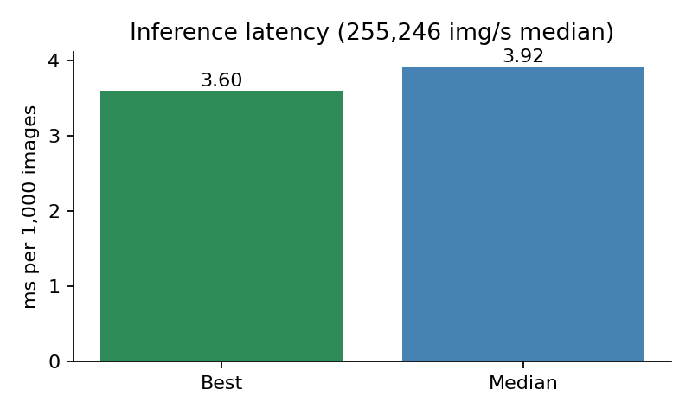
Figure 4. Inference latency for a 1,000-image batch.
Median latency is 3.92 ms per 1,000 images. The notebook also draws a strip of ten test digits with green/red titles for correct and wrong predictions; the printed output has no text for it, so its results are not known.

4. Observations and recommendations

Notebook 3: loan decisioning
- Model mismatch. The loaded file is a 350M-parameter "base" (not instruction-tuned) Granite model at f16, while the cell expects a 2B instruct Q4_K_M build. Base models follow structured prompts less reliably, which may explain the truncated "Evidence" line. Point MODEL_PATH at the intended file, or update the expected-name text.
- Acceleration not demonstrated. The zDNN library is shown as 0.0 MB, GPU offload is False, and the flag list is typed text. Add a timing comparison with and without zDNN, or read llama.cpp's start-up log for the back ends it registers. The text also mixes "z16" (build flags) with other pages that mention z17.
- Truncated feature output. Increase the generation token limit or stop printing the partial evidence line.
- Decision relies on an unprinted record. The recommendation cites credit score and DTI, but the loan row is not shown. Print summarize_applicant(loan) so reviewers can check the claims. In a real lending setting the LLM output should be treated as advisory, with the XGBoost score and policy rules as the decision basis, and with fair-lending review.
- Single applicant. Only applicant 5 is run, so there is no evidence of how the pipeline treats high-risk or borderline cases.

Notebook 4: MNIST
- Constant validation metrics. val_accuracy 0.9628 and val_loss 0.1427 repeat in all five epochs. Re-run the cell from a fresh kernel and confirm the history values differ per epoch.
- Accuracy below typical. 95.05% test accuracy is a little low for this network; check preprocessing and that the model was not trained on a stale state.
- Acceleration claim is unverified, as in Notebook 1. The op list is printed text and the device list shows only CPU.
- Small cosmetic issues. A stray "mnist.train.xs" heading line appears in the markdown, and tensorflow is imported twice.

